NATIONAL INSTITUTE OF TECHNOLOGY KARNATAKA SURATHKAL

DEPARTMENT OF INFORMATION TECHNOLOGY

**IT 301 Parallel Computing LAB 8**

14th October 2020

**Faculty: Dr. Geetha V and Mrs. Thanmayee**

**Name:** Chinmayi C. Ramakrishna

**Roll No.:** 181IT113

1. **MPI “Hello World” program:**

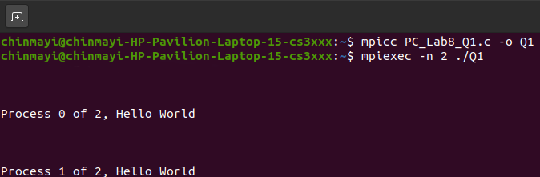

Hello World is printed once for each process.

1. **Demonstration of MPI_Send() and MPI_Recv(). Sending an Integer.**

**Code:**

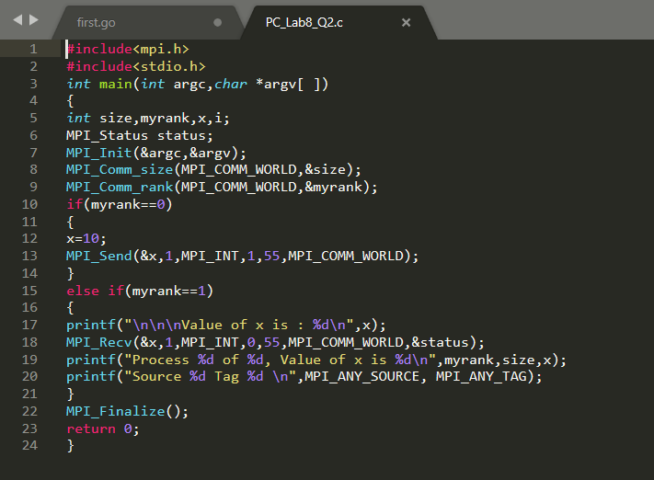

**Output:**

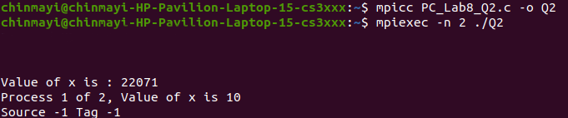

 Mpi_any_source tells MPI to receive the message without restricting the rank of the sender.Mpi_any_tag tells MPI to give any tag to the process.

1. **Demonstration of MPI_Send() and MPI_Recv(). Sending a string.**

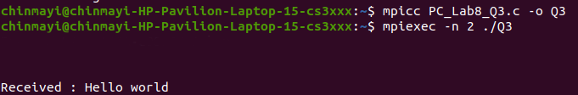

The message sent by process 0 is successfully received by process 1.

1. **Demonstration of MPI_Send() and MPI_Recv(). Sending elements of an array.**

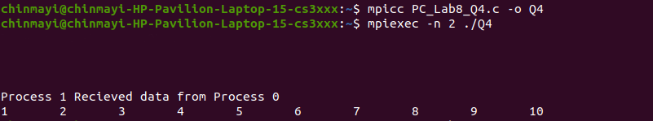

A count of first 10 messages is successfully received by process 1 from process 0.

1. **Demonstration of Blocking Send and Receive with mismatched tags.**

**Output:**

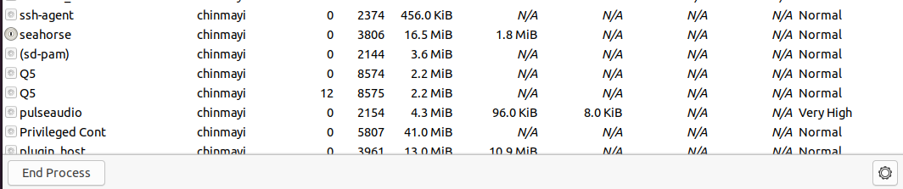

Process when it’s being executed.

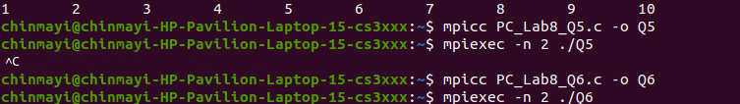

The process ends when the code is exited.

1. **MPI_Send() and MPI_Recv() standard mode:**

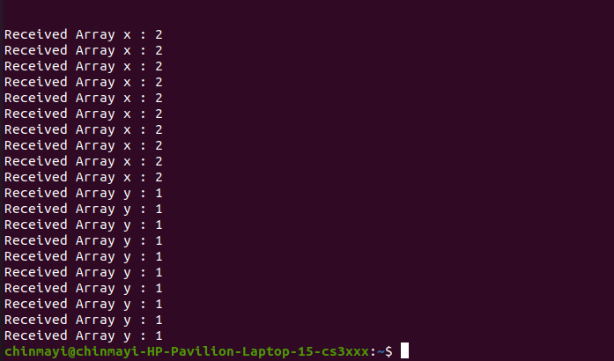

1. **Note down your observation on the content of x and y at Process 1.**

The value of x is not received as the tags of the send of process 0 and receive of process 1 do not match.

The value of y is not received as the tags of the send of process 0 and receive of process 1 do not match.

**b) Explain the importance of tag.**

When process 1 wants to send many different types of messages, it can use ids called tags so that the receiver can differentiate the messages.

**c) Write your analysis about Blocking Send and Receive. Whether it is advantageous?**

The buffer passed to mpi send can be reused. Mpi receive returns when the receive buffer has been filled with valid data.

**d) What is the need for Non-blocking Send and Receive?**

The use of non - blocking receives may also avoid system buffering and memory-to-memory copying, as information is provided early on the location of the receive buffer